 |  | Mathematics Essentials 2016  Unit 3/4 Test 5  Task Weighting: 6%
Student Name:

Time Allowed: 55 Minutes Total Marks: 45

Calculators and files are allowed in this test.
Answer all of the following questions. Show all working where appropriate to maximise marks.

Question 1 (4 Marks: 1, 1, 1, 1)
Convert the following to 24 hour time;

- 11.30 am

- 7.00 pm

Convert the following to 12 hour time;

- 1600 h

- 1335 h

Question 2 (5 marks: 1, 1, 2, 1)

In 2012 the Olympics were held in London, which is 0 GMT. In 2016 the Olympics were in Rio de Janeiro, which is -3 GMT. If Perth is +8 GMT;

- What is the time difference between London and Perth?

- What is the time difference between Rio de Janeiro and Perth?

- In 2016, the Olympics Opening Ceremony was held on Friday at 7.30 pm in Rio de Janeiro. Ignoring daylight savings, what day and time would you have expected to watch it live in Perth?

- In the summer, Rio de Janeiro observes daylight savings, but Perth does not. In summer, what is the time difference between Rio de Janeiro and Perth if you take daylight savings into consideration?

Question 3 (1 mark)

Explain why Honolulu (21°N 157°W) and Barrow (71°N 157°W) have the same time.

Question 4 (5 marks: 2, 3)

Perth is located at 31°S 115°E and Rio de Janeiro is located at 22°S 50°W.

- A 15° change in longitude corresponds to a 1-hour time difference. Use a calculation to show that there is an 11-hour time difference between Perth and Rio de Janeiro.

- Sally took a non-stop flight to Rio de Janeiro that left Perth at 6.00 am on Saturday. The flight took 14.5 hours. What was the day and time of her arrival in Rio de Janeiro?

Question 5 (6 marks: 1, 1, 1, 3)

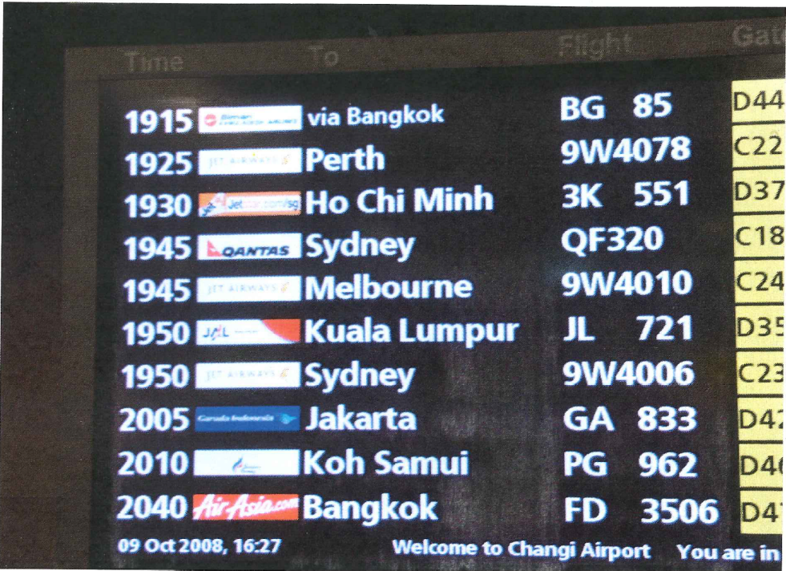

Use the photo supplied to answer the following questions using the fact that Changi airport is in Singapore which has the same time as Perth (in October).

- Tim is catching the plane to Perth. How long before it leaves?

- How much time will elapse between the departures of flights BG 85 and FD 3506 if they both leave on time?

- The flight to Perth takes 5 hours. What time will it arrive in Perth?

- If the 9W4006 flight to Sydney is delayed by 3 hours and Sydney time is two hours ahead of Singapore time, state the date and time of arrival if the flight takes 5 hours and 55 minutes.

Question 6 (4 marks: 2, 2)

Steven buys a refrigerator on credit for $1200. He pays for the refrigerator in monthly instalments over the course of two years. Interest is added to the loan at a simple interest rate of 7% p.a.

- How much interest will be added to the loan over the two years?

- Calculate Steven’s monthly repayment

Question 7 (3 marks)

Complete the table below by converting the interest rates;

Yearly Interest Rate | Quarterly Interest Rate | Monthly Interest Rate
12% pa | 3% per quarter | 1% per month
7% pa
 | 6% per quarter
 |  | 1.5% per month

Question 8 (2 marks)

The graph below compares the growth of an investment calculated with compound and simple interest. Label the graph to distinguish which is which.

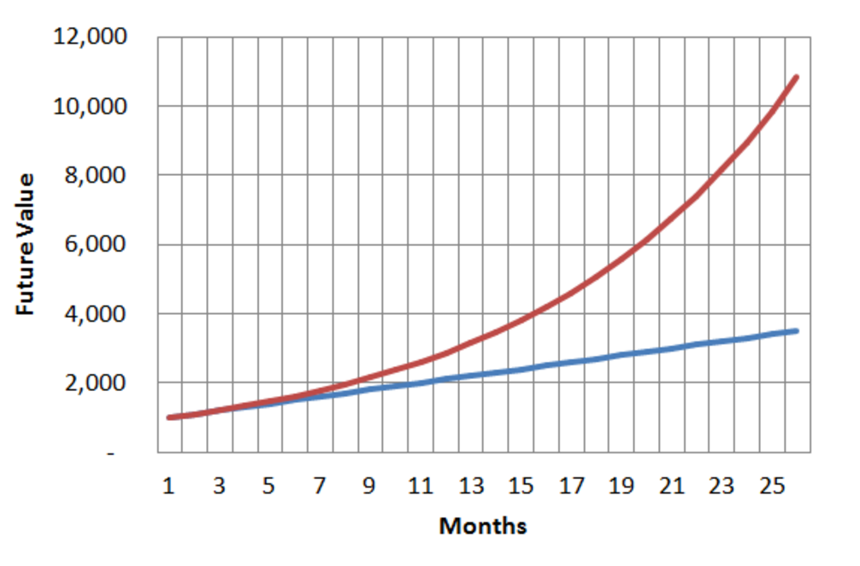

Question 9 (2 marks)

List two other real life situations, apart from compound interest, where values are compounded over time.

Question 10 (7 marks: 5, 2)

Janette wins $10,000 in the lottery. As she is sensible, she decides to invest the money. She has two options:

Bank A: Offers an interest rate of 10.5% p.a. compounded yearly

Bank B: Offers an interest rate of 9.95% p.a. compounded half-yearly.

- Complete the two tables below to compare the two investment options:

Bank A

Period | Opening Balance | Interest | Closing Balance
1
2
3
4

Bank B

Period | Opening Balance | Interest | Closing Balance
1
2
3
4
5
6

- Which investment option would you recommend? Explain your answer.

Question 11 (6 marks: 4, 2)

Jethro borrows $9500 to buy a car. He makes monthly repayments of $330 (except the final repayment) over a 3 year period to pay off the loan. He is charged 15% pa. compound interest compounded monthly. The table below shows part of the progression of this loan.

Month | Amount Owing | Interest | Repayment | Balance
1 | $9500.00 | $118.75 | $330.00 | $9288.75
2 | $9288.75 | $116.11 | $330.00 | $9074.86
3 | $9074.86 | $113.44 | $330.00 | $8858.30
4 | $8858.30 | A | $330.00 | B
…. | …. | …. | …. | ….
34 | $936.23 | $11.70 | $330.00 | $617.93
35 | $617.93 | $7.72 | $330.00 | $295.65
36 | $295.65 | C | D | $0.00

- Determine the values of A, B, C and D from the table above.

A = ________ B = ________ C = ________ D = ________

- Determine the total amount of interest paid by Jethro over the period of the entire loan

END OF TEST

